# Empathy Map

|  |  |
| --- | --- |
| **Date** | **30 JUNE 2025** |
| **Team ID** | **LTVIP2025TMID47465** |
| **Project Name** | **Cosmetic Insights: Navigating Cosmetics Trends and Consumer Insights with Tableau** |
| **Maximum Marks** | **4 Marks** |

## Empathize & Discover

An Empathy Map is a powerful tool used to visualize the emotions, motivations, goals, and challenges of our target users—in this case, cosmetic consumers. This helps teams understand the real user behind the data and make design or business decisions that truly address their needs.  
  
The goal is to use data storytelling in Tableau to reflect consumer perceptions, preferences, and frustrations in the cosmetics industry.

## Empathy Map Canvas – Cosmetics Consumers

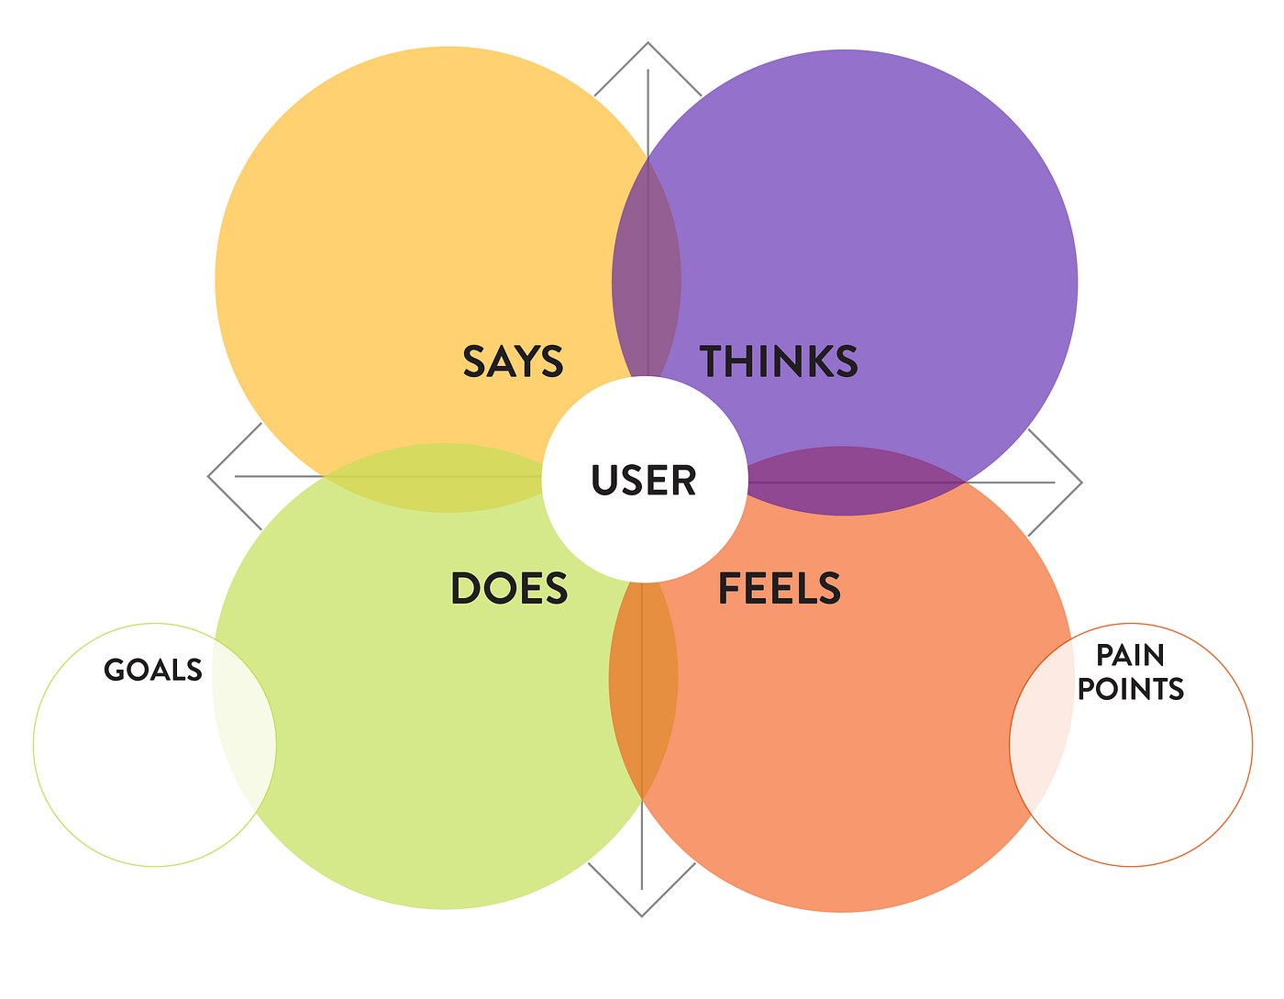

### User Persona:

- Name: Priya  
- Age: 26  
- Location: Hyderabad  
- Occupation: Working Professional  
- Shopping Habits: Prefers online platforms like Nykaa, Amazon  
- Skincare Priorities: Natural ingredients, dermatologically tested, reviews matter

### Says:

- “I want a product that suits my sensitive skin.”  
- “Is this brand cruelty-free?”  
- “I rely on customer reviews before buying.”

### Thinks:

- “Will this really work for my skin type?”  
- “Is the price justified by the quality?”  
- “Are these ingredients safe and non-toxic?”

### Does:

- Searches for product comparisons and reviews  
- Follows beauty influencers on Instagram and YouTube  
- Tracks discounts and flash sales

### Feels:

- Excited to try new cosmetic trends  
- Anxious about skin reactions  
- Frustrated by overwhelming options